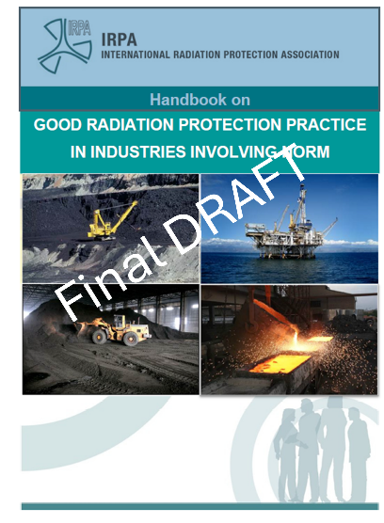
The IRPA Handbook on Good Radiation Protection in Industries involving NORM: A Practitioner’s Book

Comment Form
The handbook has been developed over more than five years by a dedicated team of practitioners brought together by IRPA. The handbook aims to be different and talk about what we all do in practice.
The authors would greatly appreciate your comments.
Please use the table below to record comments and suggestions on the final draft Handbook, noting the relevant page number and paragraph reference for each comment. Email the completed form to norm@irpa.net.

Reviewer name: ____________________ | Date: ____________________ | Organisation: ____________________
Page | Paragraph | Comment

